Polix™ Traffic Signal Heads
Q200 Pedestrian&Vehicle Signal Head with Power LEDs

TECHNICAL SPECIFICATIONS
- Unique Colour Brightness
- Phantom Class 5
- Homogeneous Light Distribution
- High Impact Resistance
- Low Harmonic Distortion
- Flexible Polycarbonate UV Housing
- Power Factor >0,9
- Low Power Consumption

High Quality Driver
Traffic signal heads are manufactured with high lifetime expectance since they affect traffic flow directly. Therefore, polix optimizes long life expectancy as well as its LED driver technology Optimal circuit design optimizes the efficiency to increase the lifetime just like it’s LEDs.

Environmental Compatibility
With its voltage fluctuation tolerance, EMI filter, -40~+70 operating temperature and 170V ~ 265V operating voltage, the Polix Series are robust against grid faults and environmental conditions.

Ingress Protection
The traffic signal heads are continuously interacting with environmental factors as they operate outside. Polix Models are resistive against moisture, dust and air flow with its IP65 protection level. The signal head's internal structures improve the product efficiency with its structure which is not affected by these variables.

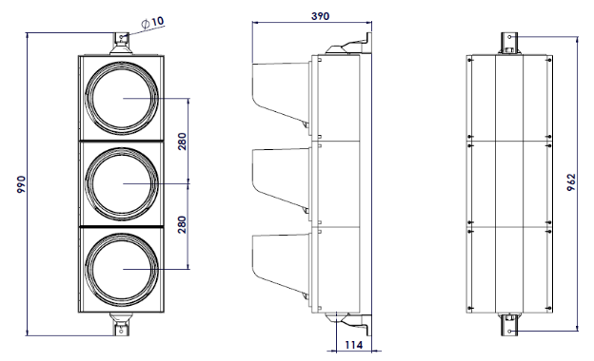

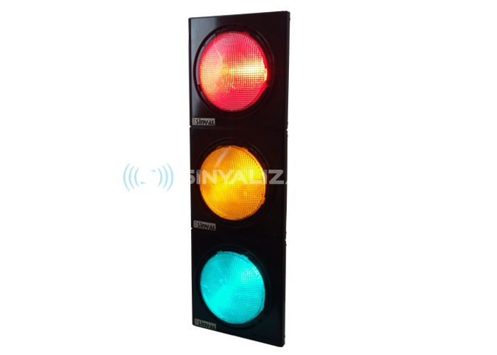

Flexible Polycarbonate Housing
Polix models manufactured using polycarbonate raw material, which is used widely amongst signal heads in the world, include UV additives to increase its resistance against harmful solar radiation. It is also an environmentally friendly product since it is composed of recyclable raw materials. Housing production is made in the desired color in accordance with the need.

EN 12368
Polix™ Series are produced in compliance with EN 12368:2015 standard which includes the visual, structural, environmental performances and the tests of 200mm and 300mm signal heads produced for pedestrian and road traffic use. In addition, EN 50293 EMC standard is provided under this standard during the production and testing stages.

2 Years Warranty
Polix™ Series are controlled at every stage of production with the assurance of Sinyalizasyon Electronics. Production and test reports are stored in the production files for each product produced by giving it a product-specific serial number. In this way, we have information on all production and testing stages of the product that needs to be intercepted under warranty.

Q200 Pedestrian & Vehicle Signal Heads with Power LEDs
TECHNICAL SPECIFICATIONS
TECHNICAL SPECIFICATIONS

Minimum Shutdown Voltage | 80V
Reaction on/off | < 50 ms
LED | Red, yellow and green for high brightness power LEDs
Luminous Intensity | Min 400 – Max 800
Signal Symbol | S1
Power Consumption(Watt) | < 8 W
EMC | EN 50293
Total Harmonic Distorsion | <%10
Light Distribution | 1 / 2.5

Product Code | Q200POL-Q200PLY
Diameter | 200mm
Housing | Polycarbonate UV.
Housing Colour | Black
Impact Resistance | IR3
Vibration | Class AJ3
Ingress Protection | IP65
Operating Temperature | -40°C to +60°C
Operating Voltage | 170-265 V

Model Number |  | Front Lens | Size  (mm) | Frequency | Module’s Weight (kg) | Cable Cross Section/ Lenght | Wavelength  (nm) | Luminous Intensity _{(Cd)}
 | Q200PL-RED | Gray/ Transparet | 200 | 45-55 Hz | 1.2 | 2 x 0.75mm²/1 m | 625 | >400
 | Q200PL-YELLOW | Gray/ Transparet | 200 | 45-55 Hz | 1.2 | 2 x 0.75mm²/1 m | 589 | >400
 | Q200PL-GREEN | Gray/ Transparet | 200 | 45-55 Hz | 1.2 | 2 x 0.75mm²/1 m | 502 | >400
1 Some values can be changed according to requirements in a way that does not constitute a violation of 12368 standards.
2 Please contact our sales consultant for higher values.
3
